**Armament Detection And Alerting System**

**Using YOLOV3**

Shashank Shet K Parth P Shah Rohith.R

K S Institute of technology K S Institute of technology K S Institute of technology

*(of Affiliation) (of Affiliation) (of Affiliation)*

Visveswaraya Technological University Visveswaraya Technological University Visveswaraya Technological University

Bengaluru, India Bengaluru, India Bengaluru, India

[shashankshetk@gmail.com](mailto:shashankshetk@gmail.com) [parthpshah157@gmail.com](mailto:parthpshah157@gmail.com) [rohi1999@gmail.com](mailto:rohi1999@gmail.com)

|  |
| --- |
|  |
|  |

Assistant professor Mr. Roopesh Kumar B.N

Bengaluru, India

roopeshkumarbn@ksit.edu.in

***Abstract*— Based on current circumstances around the world, there is major need of smart surveillance for security to detect weapons and alert the public. The objective here is to develop a prototype which will visually detect the weapons in real time videos and alert upon successful detection. We have worked around this using an algorithm called YOLO-V3. We used a custom dataset of weapons to implement this. The model was implemented to detect weapons in different scenarios with varied parameters like shapes and scales. Further we have integrated the same with twilio api which will send a call alert upon successful detection**

***Keywords—YOLOV3; Armament detection;***

# I. INTRODUCTION

The number of crimes involving arms violence is increasing throughout the world, especially in that places where the possession of guns is legal. Looking at the data above, it is very clear that ferocity involving weapons are going up day by day and it is increasingly becoming a task for law enforcement to keep this issue in control on time.

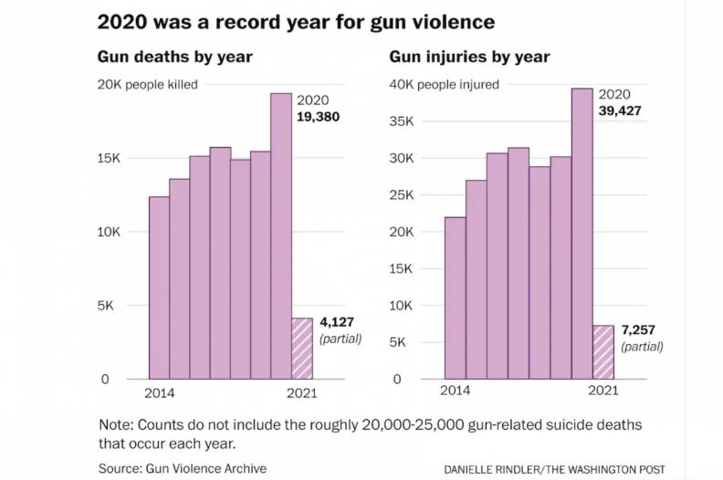

The nostrum for this issue is real time detection of weapons using surveillance system and raising an alert upon successful detection which can help to reduce this kind of sadism and assist the police or security agents to respond in less time. The field of machine learning mainly in object detection and classification of objects has been transformed by deep learning. You look only once that is YOLO algorithm outmatched other object detection algorithms at prediction. [1].

In this paper, we present smart weapon detection and alerting system using YOLOv3. Detecting guns in a scene is a very demanding issue due to of various problems linked with it. The issues in weapon detection is mainly caused due to obstruction. weapon to background and weapon to object are the two types of weapon obstruction. Live processing is another major difficulty in weapon detection system that arises during detection of the target object. The remaining part of the paper is divided as follows: section 2 tells about the related work, section 3 outlines the methodology, section 4 explains the proposed design and section 5 marks out the implementation. Section 6 describes the working of motion detection. Finally, in Section 7 we conclude with the results and section 8 contains the references.

# II. RELATED WORK

In [3], researchers used 3D millimeter wave imaging technique to detect the weapon concealed in the body and other hidden location.

In another work [3], researchers deploy a real time gun classifier that detect and classify guns. They used ImageNet dataset for training their model and acquired a mAP of 89% using overfeat-3 algorithm. The research work [4], is based on terahertz human dataset used in deep learning to detect the concealed weapon. The achieved a competitive accuracy compared to other concealed weapon detection system.

III METHODOLOGY

Methodology has been classified as below:

# i. DATASET

For this model we have formulated a dataset consisting of weapons. We have validated and trained our YOLO v3 model for satisfactory results. The following was used to evaluate our weapon detection system. Few example are displayed in Figure 1 that demonstrates the images used in training our yolo model.

# ii. YOLO-V3 ALGORITHM

Transfer learning has been utilized for implementing out model using YOLO V3 for weapon detection using the weights trained by us.

You Only Look Once(YOLO) version 3 is algorithm is used for object detection. The given image is split into M × M mesh. An object is predicted by a cell in this mesh.

Logistic regression is utilized to envision an object scores for each bounding box by YOLO V3 to compute the cost function. If a weapon is overlaid by a bounding box before more than others, the score of the resulting object should be 1. There is nil cost obtained for overlap greater than predefined threshold 0.5.

  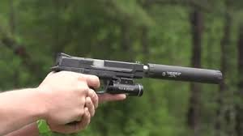

Figure 1: Some images used in training yolo model.

Only a single boundary box prior is linked with each real object. If bounding box before is not assigned, no categorization and localization loss occurs, only confidence loss on objects is incurred. The computation of the loss is done using the following.



Where are obtained using sigma function with the between the range 0 and 1. The network computes 5 coordinates for each bounding box



=



and



are loss function and



and



.



and



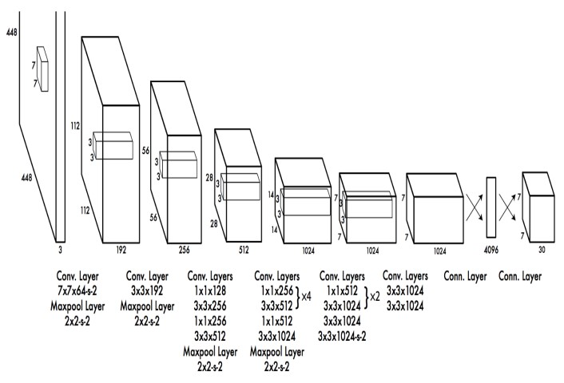

Figure 2: block diagram of YOLO-V3

The class forecast from the cell level is moved to the bounding box level. Now, each prediction contains four parameters for the bounding box and one confidence box score, the weapon prediction predicts the Intersection over union of the ground truth.

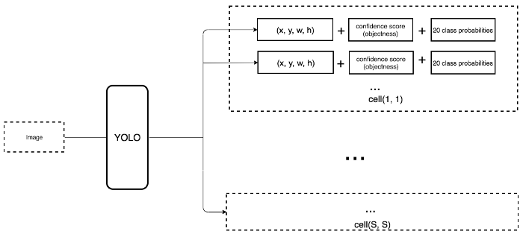

Figure 3: Class forecast from cell to bounding box level

IV. PROPOSED DESIGN

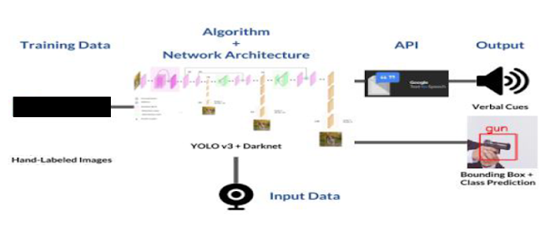

We have taken certain image dataset and then to train the model in yolo we have labeled the images. For labeling we utilized a software called LabelImg. Using this software, we obtain text files which are associated with each image. These text files consist of number of objects present, the x and y coordinates and height and width of the image. This manually hand labeled dataset was used to train our weapon detection model. After training we obtained our yolo weights file and therefore the weight file which we obtained was used for implementation of weapon detection system. If a gun is detected in the frame, an alerting system using twillio api will invoke and it will send an alert to the subscribed user.

V.IMPLEMENTATION

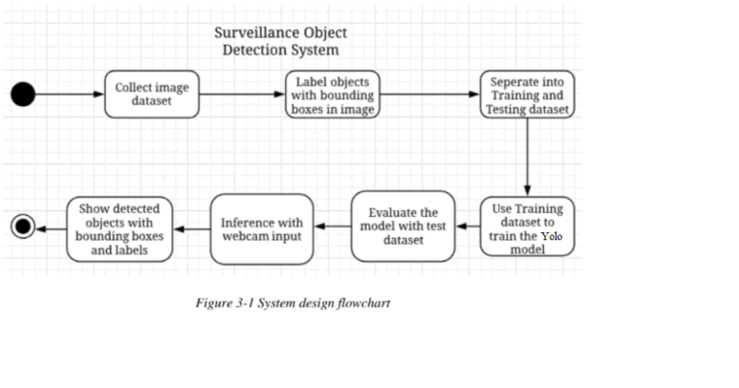

The Implementation of the weapon detection and alerting system is as follows: We utilized hand labeled data to train the model. Here to train the data in yolo we label the images first using a software called Labelimg. Using this we have manually labeled all the images from the data set. The detection of weapon is done by our yolo model. The darknet framework is used to extract features from different layers which will help us know the features of the target object. Then the bounding box is used to specify the object location and if any weapon is detected within the frame then an alert will be sent to the user through twilio api.

VI. MOTION DETECTION

In order to detect motion from live feed, we calculate the Pythagorean distance between two frame. Further we use standard deviation to calculate where the motion is significant enough to trigger an alarm. If the standard deviation is greater than the threshold set value, then we start the weapon detection. We initialize global variables and functions. We also used variables for setting the motion level threshold and display font. "sdThresh" is used for motion level threshold and "font" is used for setting for for text display on video. We calculate the difference between two frames and output its Pythagorean distance. Utilizing the difference between two frames we get frame 3's columns and rows matrix. We also Apply Gaussian smoothing to even out our distance mapping.

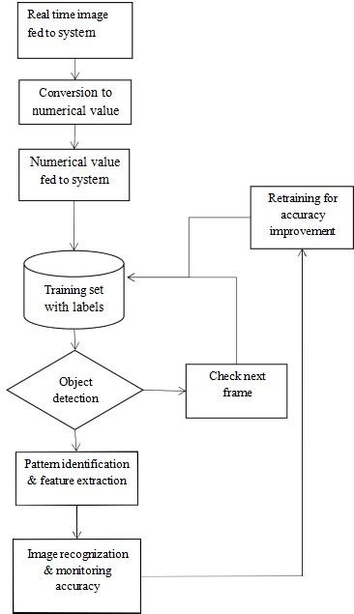

General block-diagram of the proposed model.

At this point, we obtain a binary array that indicates when motion has occurred and when it has not. Then, we use standard deviation to calculate where the motion is significant enough to trigger an alarm. The next step constitutes to calculate the standard deviation. If standard deviation is more than our threshold, then we print a message.

"Motion detected.. Do something!!!”

## VII. RESULTS AND DISCUSSION

Detecting guns in videos not only focus on gun detection but also emphasis on minimizing the number of false positives and providing real time detection.

We have estimated YOLO-V3 based classification model considering a single class to specify the presence of weapon. However, this paper is to check how our YOLOv3 neural network model behaves when used in detection of weapons. The detection results are examined frame by frame in the videos during the experiments and measured a detection as true positive if the gun and bounding box overlapping is more than 50%.

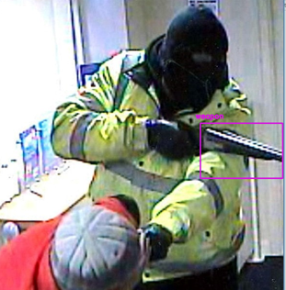 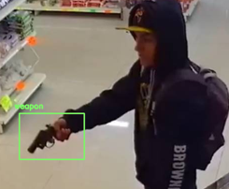

Figure 3: an example of accurate weapons detected in two different frames

## V. CONCLUSION

The objective was to develop a real time weapon detection system and alerting system with minimum false positive using YOLOv3 algorithm. YOLOv3 based model has been trained with a dataset containing our own custom dataset. It is clear that YOLOv3 has a good detection.

False negative can be used to explain low recall in the video’s frame which is due to the detection of weapons in an obstructed environment or when the weapon is moved quickly.

The false negatives strongly rely on the frame quality and when the weapon is visible clearly.

# VIII. REFERENCES

[1] Redmon, Joseph, Santosh Divvala, Ross Girshick, and Ali Farhadi. "You only look once: Unified, real-time object detection." In *Proceedings of the IEEE conference on computer vision and pattern recognition*, pp. 779-788. 2016.

[2] Tiwari, Rohit Kumar, and Gyanendra K. Verma. "A computer vision-based framework for visual gun detection using harris interest point detector." *Procedia Computer Science* 54 (2016): 703-712.

[3]Arceda, V. Machaca, K. Fernández Fabián, and Juan Carlos Gutíerrez. "Real time violence detection in video." (2016): 6-7.

[4] Akcay, Samet, Mikolaj E. Kundegorski, Chris G. Willcocks, and Toby P. Breckon. "Using Deep Convolutional Neural Network Architectures for Object Classification and Detection Within X-Ray Baggage Security Imagery." *IEEE Transactions on Information Forensics and Security* 13, no. 9 (2018): 2203-2215.